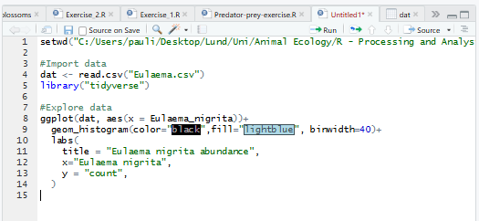

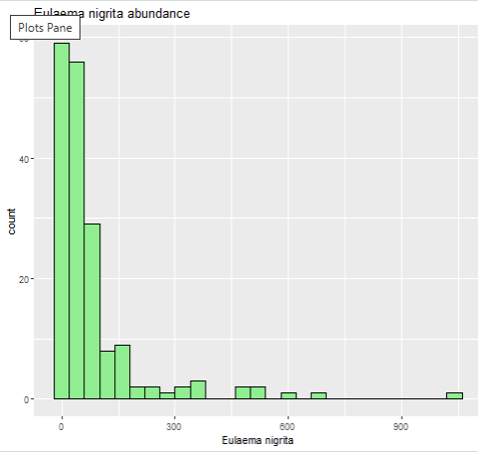

Abundance of Eulaema nigrita
Variables: climate (
- mean annual temperature MAT *10
- annual precipitation – mm
- temperature seasonality – Tseason, 100 * SD
- and precipitation seasonality – CV of mm
- land use: proportion forest cover
- and land use heterogeneity defined as the Shannon diversity (−Σipi lnpi) of local land-use classes

Predictions
- mean annual temperature MAT *10 -> will affect abundance, good at medium point, better higher
- annual precipitation – mm -> better if lower but over 0
- temperature seasonality – Tseason, 100 * SD -> very scattered
- and precipitation seasonality – CV of mm -> medium point best
- land use: proportion forest cover -> better if less cover
- and land use heterogeneity defined as the Shannon diversity (−Σipi lnpi) of local land-use classes -> rather higher better

Why is the temperature seasonality measured as a standard deviation and the precipitation as a CV?
Because Temperature is measured as intervals and the 0 is trivial, can’t divide trough 0 for calculating cv.
Precipitation can’t have negative values
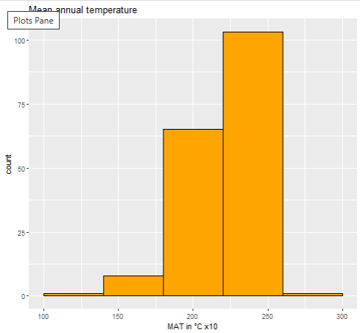
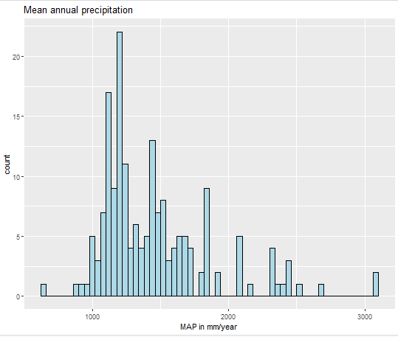

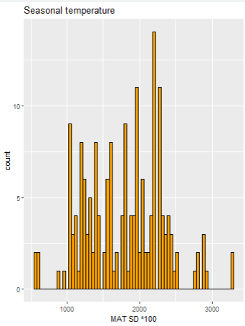

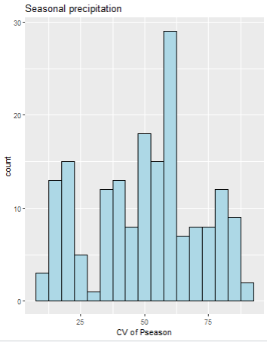
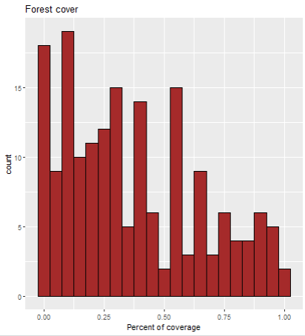
Model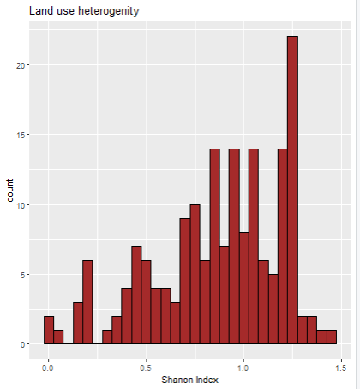
Fitting model
model3 <- glm(Eulaema_nigrita ~ forest. +lu_het,family="poisson",data=dat)
summary(model3)
but overdispersion
Null deviance: 23280 on 177 degrees of freedom
Residual deviance: 20056 on 175 degrees of freedom

Looking at habitat characteristics
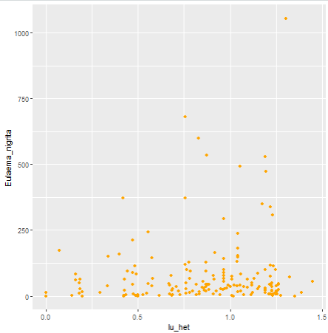
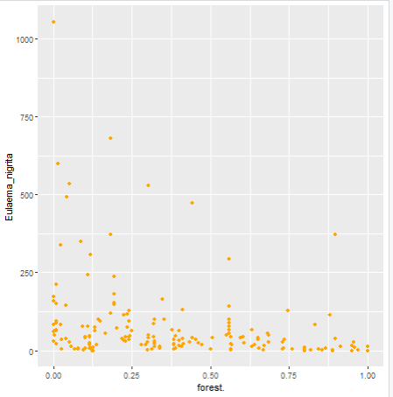
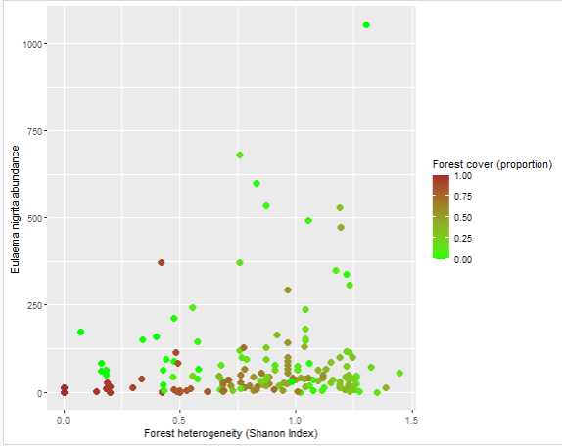

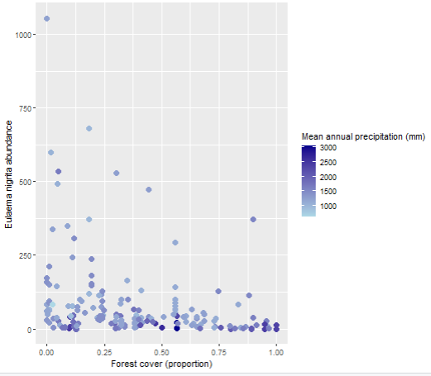

Understand how to make a new data sampling from this and make a prediction and compare it to my own data

